

St. Joseph’s Degree & PG College Department of Computer Science
Programming with C++
Semester- I Lab Manual

S no | Name of the programs
1 | Write a c++ program to check whether given number is Palindrome or not.
2 | Write a c++ Program to implement Matrices multiplication
3 | Write a c++ program to implement Functions
4 | Write a c++ program to implement Bank account Class
5 | Write a c++ program to implement Student information Class
6 | Write a c++ program to implement Constructors.
7 | Write a c++ program to find Factorial of a given number using Recursion
8 | Write a c++ program to implement Friend function
9 | Write a c++ program to implement Function Templates
10 | Write a c++ program to implement Multiple inheritance
11 | Write a c++ program to implement Hierarchical inheritance
12 | Write a c++ program to implement Function overloading
13 | Write a c++ program to implement Exceptional handling
14 | Write a c++ program to implement Class Templates.
15 | Write a c++ program to implement Virtual Functions

  - Program of palindrome
#include<iostream.h> #include<conio.h> i
nt main()
{

int n, num, digit ,rev=0; cout<<"Enter a number:"; cin>>num;
n=num; while(num>0)
{

digit=num%10; rev=(rev*10)+digit; num=num/10;
}

cout<<"The reverse of the number is:"<<rev<<endl; if(n==rev)
cout<<"The number is a palindrome"; else
{
cout<<"The number is not a palindrome";
}

getch();
return 0;
}
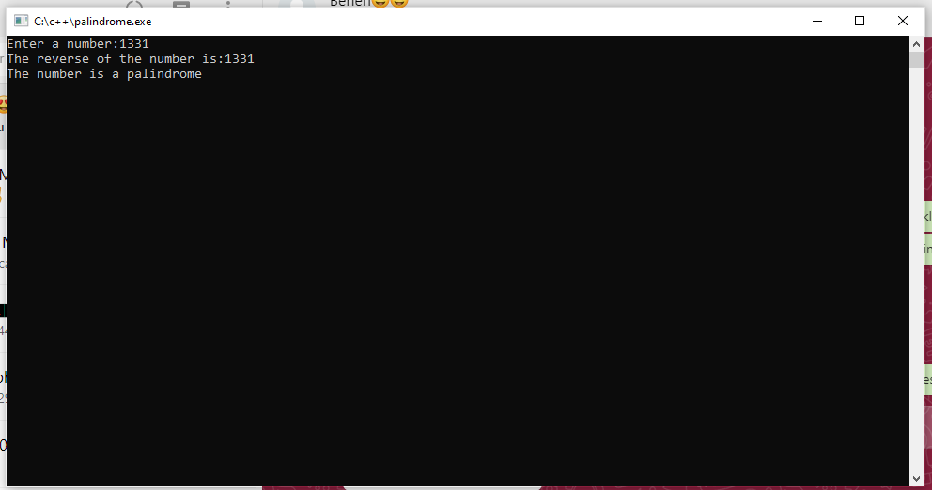

2. Matrices Multiplication Program
#include<iostream.h> #include<conio.h>
int main()
{

int a[3][3], b[3][3], c[3][3], i, j, k;
cout<<"Enter the matrix1 values"<<endl; for(i=0; i<3;i++)
{

for(j=0; j<3; j++)
{

cin>>a[i][j];
}
}

cout<<"Enter the matrix2 values"<<endl;
for(i=0; i<3; i++)
{

for(j=0; j<3; j++)
{

cin>>b[i][j];
}
}

for(i=0; i<3; i++)
{

for(j=0; j<3; j++)
{

c[i][j]=0;
for(k=0; k<3; k++)
{

c[i][j]=c[i][j]+a[i][k]*b[k][j];
}
}
}

cout<<"The product of two matrices is"<<endl; for(i=0; i<3; i++)
{

for(j=0; j<3; j++)
{

cout<<c[i][j]<<" ";
}

cout<<endl;
}
getch(); return 0;
}
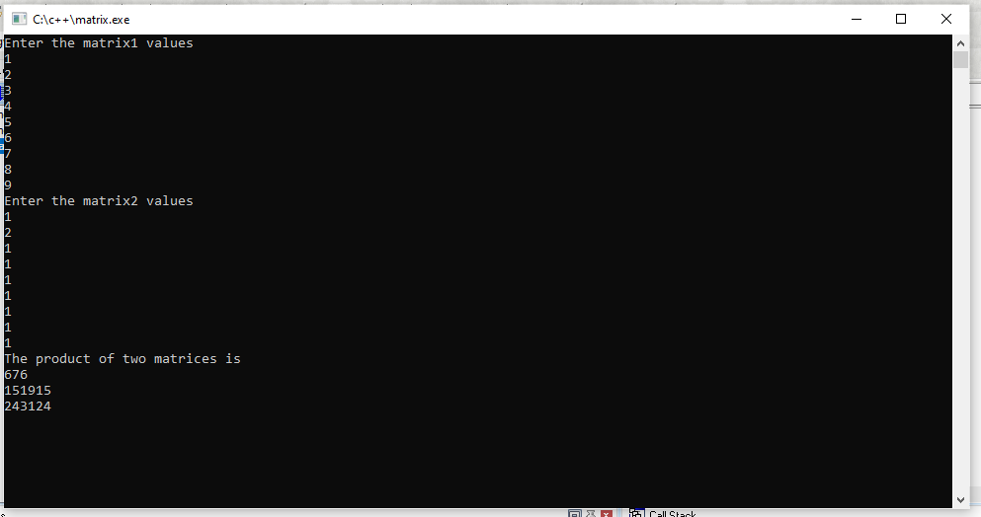

Output of product matrix program

- Program on functions
#include<iostream.h> #include<conio.h>
void add(int a,int b);
void sub(int a,int b);
void mul(int a,int b); void divide(int a, int b);
void modulo(int a,int b); int main()
{

add(20, 10);
sub(50, 30);
mul(2, 5);
divide(50, 10);
modulo(25, 4);
}

void add(int a,int b)
{

int c=a+b;
cout<<"The sum is:"<<c<<endl;
}

void sub(int a,int b)
{

int c=a-b;
cout<<"The difference is:"<<c<<endl;
}

void mul(int a,int b)
{

int c=a*b;
cout<<"The product is:"<<c<<endl;
}

void divide(int a,int b)
{

int c=a/b;
cout<<"The division is:"<<c<<endl;
}

void modulo(int a,int b)

{
int c=a%b;
cout<<"The modulo is"<<c<<endl; getch();
}
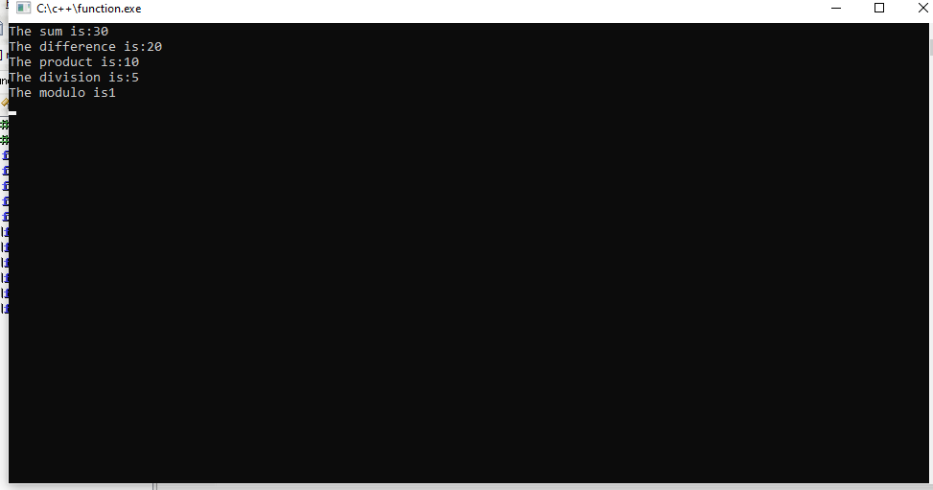
Output of functions program

- Program of bank account class
#include<iostream.h> #include<conio.h>
class BankAccount
{

int acno;
float balance;
char actype[4]; public:
void store();
void deposit(); void withdraw(); void display();
};

void BankAccount :: store()
{

cout<<"Enter account number:"<<endl; cin>>acno;
cout<<"Enter the account type:CURR/SAVG/FD:"<<endl; cin>>actype;
cout<<"Enter the current amount available:"<<endl; cin>>balance;
}
void BankAccount :: deposit()
{

float more;
cout<<"Enter the amount to deposit:"; cin>>more;
balance = balance + more;
}

void BankAccount :: withdraw()
{

float amt;
cout<<"Enter the amount to withdraw:"<<endl; cin>>amt;
balance = balance - amt;
}
void BankAccount :: display()
{

cout<<"Account Details:"<<endl; cout<<"Account Number:"<<acno<<endl; cout<<"Account Type:"<<actype<<endl; cout<<"Banalnce:$"<<balance;
}

int main()
{

BankAccount b; b.store();
b.deposit();
b.withdraw();
b.display();
getch(); return 0;
}
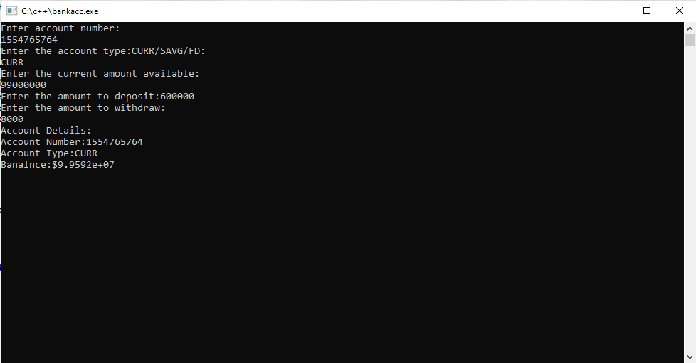
Program on student information

#include<iostream.h> #include<conio.h>
class Student
{

int rno;
float percentage; char name[20]; public:
void store()
{

Cout<<”enter the student details are \n”;
Cin>> rno >>name>>percentage;
}

void display()
{

cout<<"Roll number is:"<<rno<<endl; cout<<"Name is:"<<name<<endl; cout<<"Percentage is:"<<percentage<<endl;
}
};

Void main()
{
Student s1, s2;
cout<<"The Student 1 details are:"<<endl; s1.store ();
s1.display();
cout<<"The Student 2 details are:"<<endl; s2.store ();
s2.display();
getch();
}
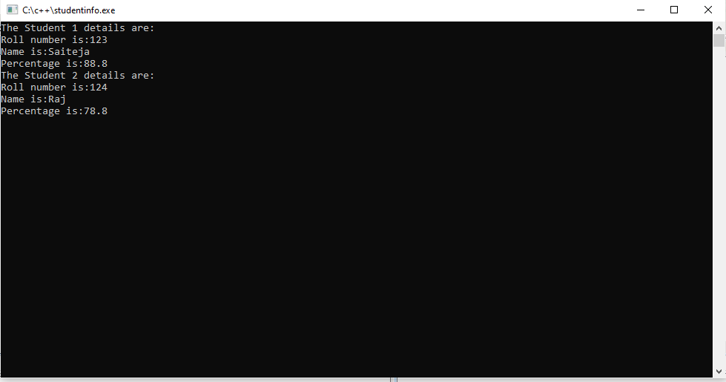
Output of student information program

- Program on constructors
#include<iostream.h> #include<conio.h>
class employee
{

int eid;
float salary; public: employee()
{

eid = 0;
salary = 0.0;
}

employee (int x,float y)
{

eid = x;
salary = y;
}

employee (employee &e)
{

eid = e.eid; salary = e.salary;
}

void display()
{

cout<<"Employee is:"<<eid<<endl; cout<<"Saalary is:"<<salary<<endl;
}
};

int main()

{
employee e1; e1.display();
employee e2(123, 18000); e2.display();
employee e3(e2); e3.display();
getch(); return 0;
}
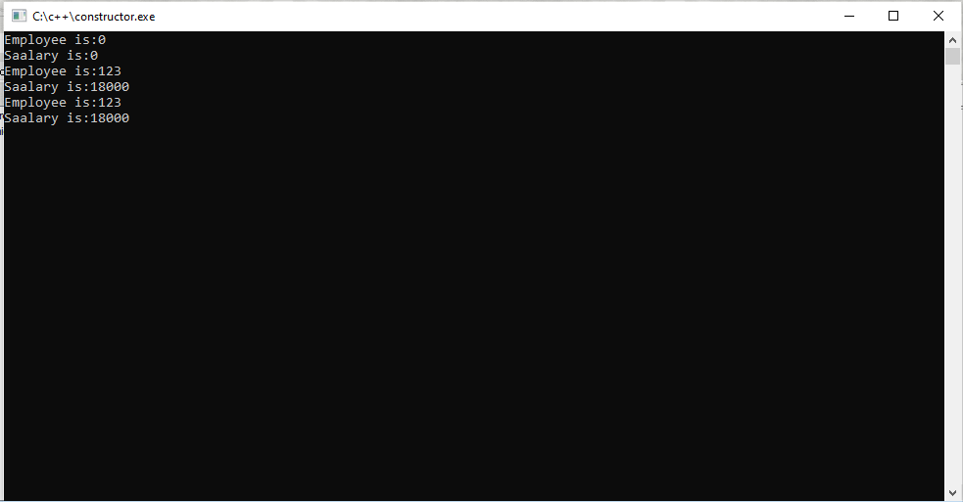

Output of constructor program

- Program on factorial
#include<iostream.h> #include<conio.h>
int fact(int n); int main()
{

int n;
cout<<”Enter the number”<<endl; cin>>n;
cout<<”The factorial of a given number is”<<fact(n)<<endl; getch();
return 0;
}

int fact(int n)
{

if (n==0||n==1) return 1;
else
return n* fact(n-1);
}
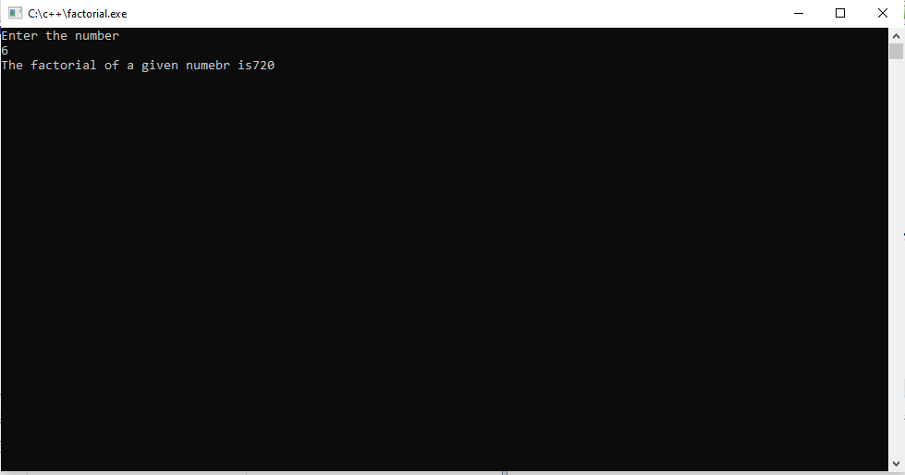

#include<iostream.h> #include<conio.h>
class Sample
{
Output of factorial program
Program on friend function

private: int a;
int b; public:
Sample()
{

a = 5;
b = 15;
}

friend void function1(Sample S);
};
void function1(Sample S)
{

cout<<"The private data members are:"<<endl; cout<<S.a<<endl;
cout<<S.b<<endl;
}

int main()
{

Sample S; function1(S);
getch(); return 0;
}
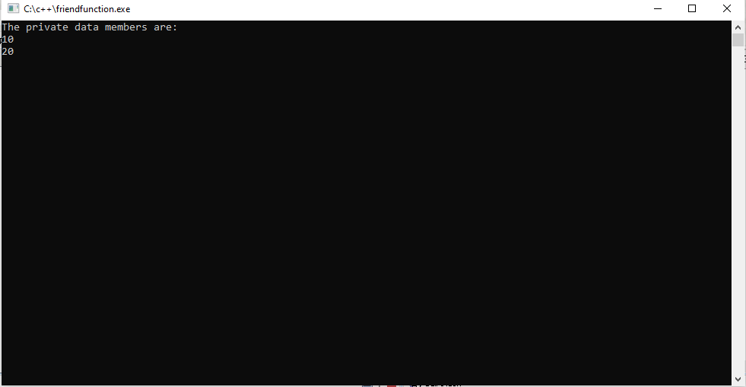

Output of friend function program
- Program on Function template
#include<iostream.h> #include<conio.h> template<class T>
T max(T a, T b)
{

if (a>b) return a; else
return b;
}

template<class F>
F min(F a, F b)
{

if (a<b) return a; else
return b;
}

int main()
{

int a,b;
cout<<"Enter a and b values:"<<endl; cin>>a>>b;
cout<<"The maximum value is:"<<max(a,b)<<endl; cout<<"The minimum value is:"<<min(a,b)<<endl;
getch();
return 0;
}
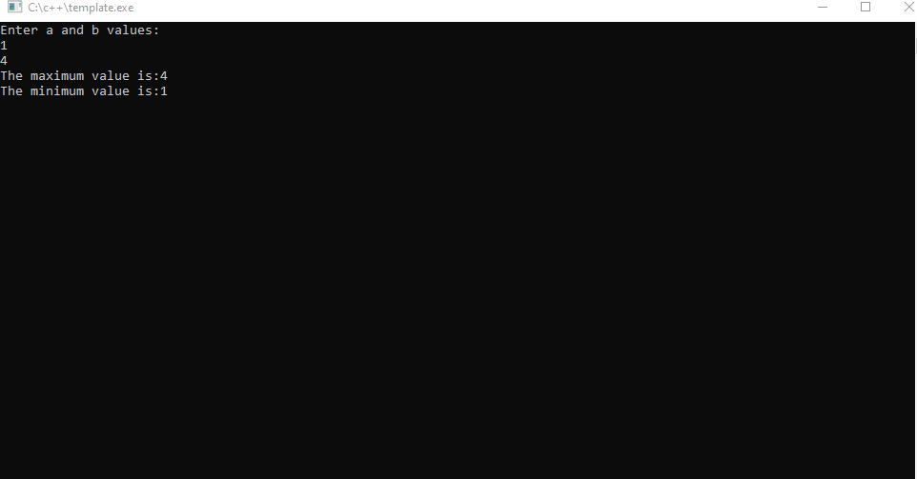

Output of template program
- Program on multiple inheritance
#include<iostream.h>
#include<conio.h> class Student
{

protected:
int rno, m1, m2; public:
void getdata()
{

cout<<"Enter the roll no:"; cin>>rno;
cout<<"Enter the two subjects marks:";
cin>>m1>>m2;
}
};

class sports
{

protected: int sm; public:
void getsm()
{

cout<<"\nEnter the sports mark:"; cin>>sm;
}
};

class statement: public Student, public sports
{

int tot,avg; public:
void display()
{

tot = (m1+m2+sm); avg = tot/3;
cout<<"\nRoll No:"<<rno; cout<<"\nTotal:"<<avg;
}
};

int main()
{
statement S; S.getdata();
S.getsm();
S.display();
getch(); return 0;
}
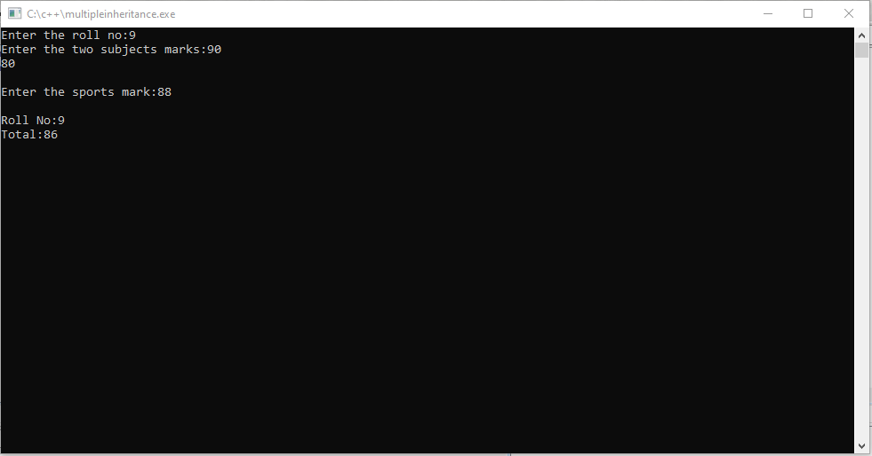

Output of multiple inheritances

- Program on hierarchical inheritance
#include<iostream.h>
#include<conio.h>
class A //single base class
{

public: int x,y;
void getdata()
{

cout<<"\nEnter value of x and y:\n"; cin>>x>>y;
}
};

class B: public A
{

public:
void product()
{

cout<<"\product="<<x*y;
}
};

class C: public A
{

public: void sum()
{

cout<<"\nSum="<<x+y;
}
};

int main()
{

B obj1;
C obj2;
obj1.getdata();
obj1.product(); obj2.getdata(); obj2.sum();
getch(); return 0;
}
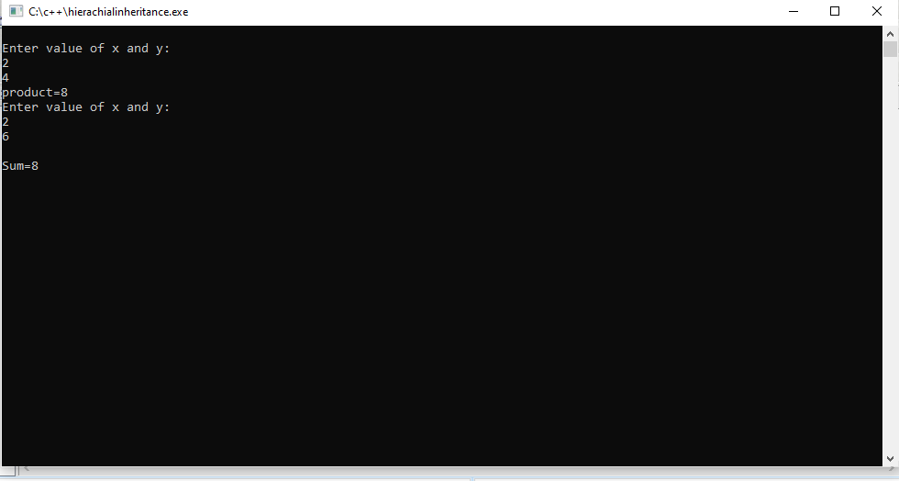

Output of hierarchical inheritance

- Program on function overloading
#include<iostream.h>
#include<conio.h
class cal
{

public:
int volume(int a) //for cube
{

return a*a*a;

}
int volume(int a, int b, int c) //for cubiod
{

return a*b*c;
}

int volume (int r, int h) //for cylinder
{

return 3.14*r*r*h;
}
};

int main()
{

cal c;
cout<<"volume of the cube is:"<<endl; cout<<c.volume(10)<<endl; cout<<"volume of the cuboid is:"<<endl; cout<<c.volume(5,10,15)<<endl; cout<<"volume of the cylinder is:"<<endl; cout<<c.volume(10,15)<<endl;
getch(); return 0;
}
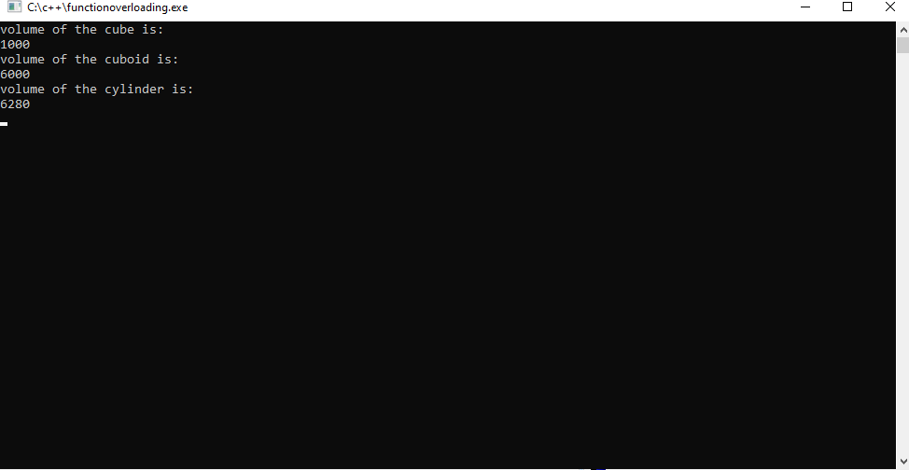

Output of function overloading program

- Program on exceptional handling #include<iostream.h>
#include<conio.h> int main()
{

try
{
int age = 15; if (age> 18)
{

}
else
{
cout<<"Access granted - you are old enough.";

throw (age);
}
}

catch (int myNum)
{

cout<<"Access denied - you must be more than 18 years old.\n"; cout<<"age is:"<<myNum;
}
getch(); return 0;
}
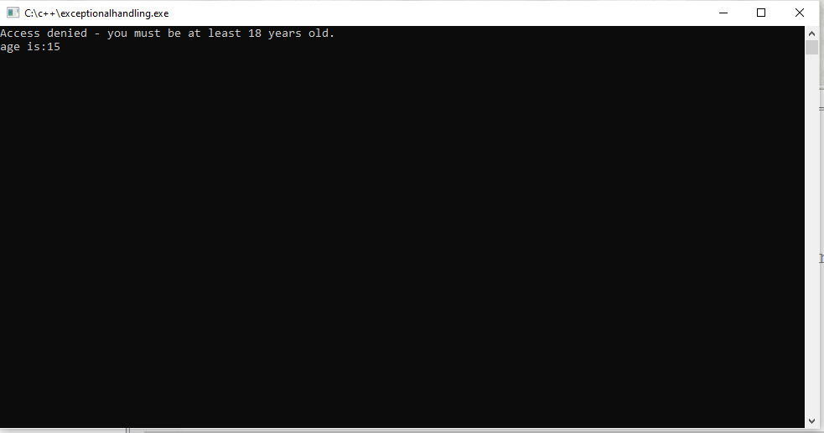

Output of exceptional handling

- Program on Class Templates

#include <iostream> #template<class T1, class T2> class A
{
T1 a;
T2 b;
public:
A(T1 x,T2 y)
{
a = x;
b = y;
}
void display()
{
cout << "Values of a and b are : " << a<<" ,"<<b<<endl;
}
};

int main ()
{
A<int,float>
d(5,6.5);
d.display();
return 0;
}

- Program on Virtual Functions
#include<iostream.h>

Class base
{
Public :
Void display()
{
Cout<<”\n display base”;
}
Virtual void show()
{
Cout<<”\n show base”;
}
};
Class derived : public base
{
Public :
Void display()
{
Cout<<”\n display derived”;
}
Void show()
{

};
void main()
{

Cout<<”\n show derived”;
}
Base b; //base class object Derived d; //derived class object
Base *bptr; //base pointer for base class Cout<<”\n bptr points to base \n”;
bptr =&b; //storing base class object in to bptr bptr ->display();
bptr ->show();
Cout<<”\n \n bptr points to derived \n “;
bptr=&d; //storing derived class object in to bptr bptr -> display();
bptr -> show();
}

Output:
bptr points to base Display base Show base
bptr points to derived Display derived Show base

